**Model Development Phase Template**

|  |  |
| --- | --- |
| Date | 25 October2024 |
| Team ID | 739894 |
| Project Title | Toxic Comment Classification for Social Media Using NLP |
| Maximum Marks | 10 Marks |

**Initial Model Training Code, Model Validation and Evaluation Report**

The initial model training code for toxic comment classification on social media will be shared through a future screenshot, showcasing the process of text preprocessing, vectorization, and training logistic regression models. The model validation and evaluation report will summarize the performance of multiple models, including their accuracy, precision, recall, F1 score, and AUC-ROC metrics, with the details presented via respective screenshots.

**Initial Model Training Code (5 marks):**

Paste the screenshot of the model training code

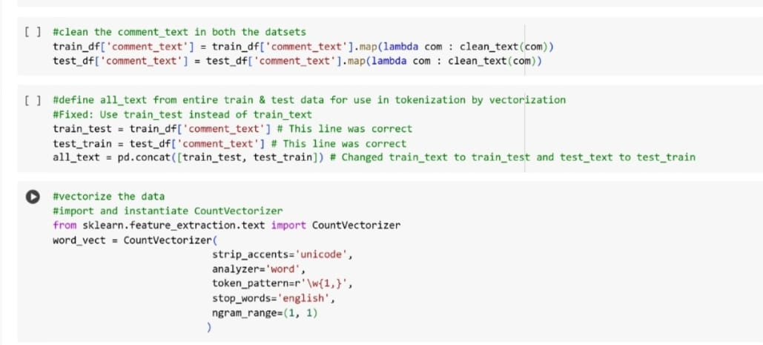

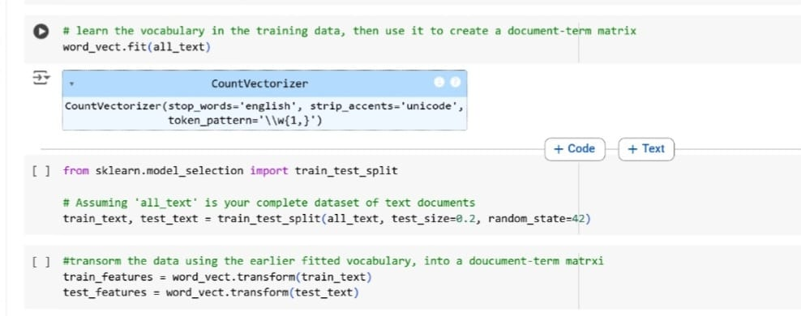**Model Validation and Evaluation Report (5 marks):**

|  |  |  |
| --- | --- | --- |
| **Model** | **Summary** | **Training and Validation Performance Metrics** |
| Model 1 |  |  |
|  |  |  |
|  |  |  |